|  |  |
| --- | --- |
| cid:image004.png@01CF7F10.A4275880 | LOGO4 |
| Best Buy Canada Mobile | |
| |  | | --- | | **Modify Item Feature Document** |   **Document Version: 1.3**  **Design Date: April 1, 2015** | |
| **Prepared By: Amy Byers** | |
|  | |

**Table of Contents**

*1.* *Feature Overview* 3

1.1 Feature Description 3

1.2 Assumptions 3

1.3 Parameters and System Settings 3

1.4 Interfaces 3

*2.* *USE CASE: Modify Item* 4

2.1 Feature Flow 4

2.2 Precondition 4

2.3 Main Flow 4

2.4 Post Condition 5

2.5 Special Requirements 5

*3.* *Supplemental Specifications* 5

3.1 Electronic Journal 5

3.2 POSLog 5

3.3 Printed Receipts 5

*4.* *Screen Layouts* 6

4.1 Modify Item 6

*5.* *Business Sign Off* 8

*6.* *Revision History* 8

*7.* *Appendix A: Glossary* 8

# *Feature Overview*

## Feature Description

The Modify Item Feature Document describes the process to access item level modifications. The Feature Document contains the use case for Modify Item and the corresponding screen mockups. Other item modification use cases are documented in their own Feature Documents but are executed from the Modify Item use case.

## Assumptions

1. All text displayed by the system is configurable by brand to support multi-language.  Text is defined from an external source or defined within the system.

## Parameters and System Settings

|  |  |  |
| --- | --- | --- |
| **Parameter Mnemonic** | **Description** | **Valid Values** |
| Item Modify Menu Options | Determines what functionality is available in the item modify menu. | * Item Void * Gift Receipt * Price Override * Manual Item Discount * Salesperson Capture * Tax Override * Tax Exempt * Raincheck |
| Raincheck Eligible Item Attribute | The item attribute that determines if the item is eligible for raincheck (ATTR_ID = 49). | * On * Off |
| Price Override Allowed Item Attribute | Determines if price override can be applied to the item. | * On * Off |
| Manually Discount Item Attribute | Determines if the item is eligible for manual item discount. | * On * Off |
| Quantity Override IBH | Determines if the IBH is eligible for Quantity Override | * On * Off |
| IBH Override | Determines if the IBH Override feature is enabled for device | * On * Off |

## Interfaces

|  |  |
| --- | --- |
| **Interface** | **Description** |
| None |  |

# *USE CASE: Modify Item*

## Feature Flow



## Precondition

* The operator has selected to modify an item in the transaction.
* Only features eligible on the items are displayed.

## Main Flow

1. The system displays the item modification options and prompts the operator to select an option.
2. If the operator selects to override the price of an item, the Price Override use case is executed.
3. If the operator selects to manually discount the item, the Manual Item Discount use case is executed.
4. If the operator selects to capture salesperson on the item, the Salesperson Capture use case is executed.
5. If the operator selects to tax exempt an item, the Tax Exempt use case is executed.
6. If the operator selects to tax override an item, the Tax Override use case is executed.
7. If the operator selects to issue a raincheck on an item, the Raincheck Issue use case is executed.
8. If the operator selects to print a Gift Receipt for the item, the system displays a visual indicator on the item marked for gift receipt, and returns to the Sale use case.
9. If the operator selects to override the quantity of the item, the system executes Capture Quantity Use Case.
10. If the operator selects to override the IBH of the item, the system executes the IBH Override Use Case.
11. If at any time the operator selects to return to the previous screen, the use case ends and the system returns to the calling use case.

## Post Condition

* The selected use case is executed.

## Special Requirements

1. The Price Override feature is only displayed for items that are eligible to be price overridden and not part of a kit or quantity required.
2. The Manual Item Discount feature is only displayed for items that are eligible to be manually discounted and not part of a kit.
3. The menu options to be displayed are determined by the Item Modify Menu Options parameter.
4. The Line Item Delete feature is not displayed if the item is an imported item from service order scheduling or MCF Web Order application.
5. The Raincheck feature is not displayed if the item is an imported item from service order scheduling or MCF Web Order application.
6. Each Transaction Type has different available options on an item.
7. Quantity Override is not available/displayed for items with mandatory serial numbers, that capture additional information, that require activation, included within a Kits on the fly, included in a parent/child relationship or which are imported.
8. Raincheck Issue is not available/displayed for items with a quantity overridden.

### Special Offline Requirements

TBD

### Data Input/Output

|  |  |  |
| --- | --- | --- |
| **Data Element** | **Description** | **Destination** |
| None |  |  |

# *Supplemental Specifications*

## Electronic Journal

Electronic journal mockups for this feature are documented in the Electronic Journal document.

## POSLog

POSLog mockups for this feature are documented in the POSLog document.

## Printed Receipts

Printed receipt mockups, where applicable, are documented in the Receipt Generation document.

# *Screen Layouts*

## Modify Item

This pop over is displayed when the operator taps the item on the Item Entry screen and prompts the operator to select an item level modification. The item level modification is listed in alphabetical order. If an item is not eligible for a specific type of modification, the modification is not displayed. <Selected Item> is replaced with the name of the item being modified. The pop over scrolls as needed.

The menu options to be displayed are determined by the Item Modify Menu Options parameter.

### Mockup

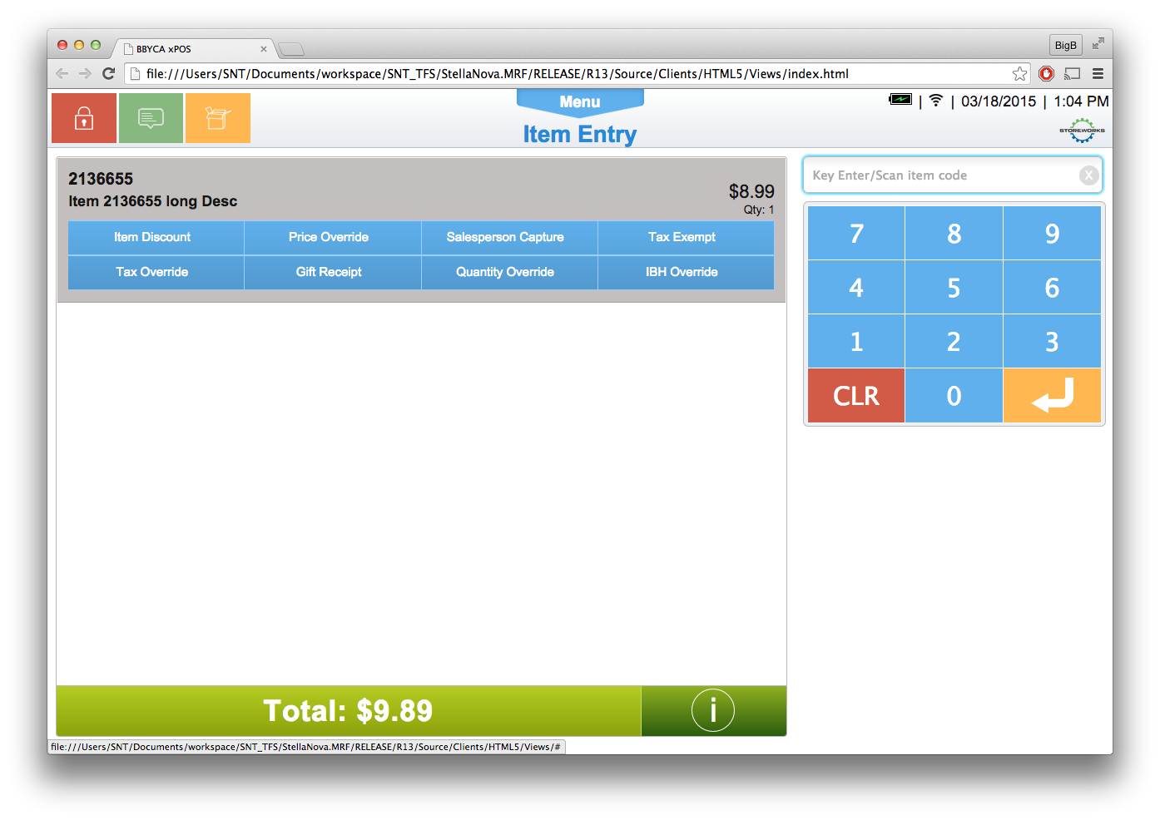

**Figure 1: Modify Item**

### Instruction Text

|  |
| --- |
| **Instructions** |
| None |

### Navigation/Menu Keys – Sale Transaction Type

|  |  |  |  |
| --- | --- | --- | --- |
| **Label** | **State** | **Next Screen** | **Notes** |
| Line Item Delete | Enabled | Line Item Delete | Disabled if the item is an imported item from the external application. |
| Gift Receipt | Enabled | Sale use case | A visual indicator on the item marked for gift receipt  **Disabled**: Transaction Type Layaway Deposit Tran Type, Pre-Order Deposit Tran Type, Raincheck Issued Item |
| Manual Item Discount | See Notes | Manual Item Discount use case | Only enabled if item has manual item discount eligible flag enabled  **Disabled**: Pre-Order Deposit Transaction Type, Raincheck Issued Item. |
| Price Override | See Notes | Price Override use case | Only enabled if item has price override eligible flag enabled.  **Disabled**: Pre-Order Deposit Transaction Type, Raincheck Issued Item. |
| Salesperson Capture | Enabled | Salesperson Capture use case | None |
| Tax Override | Enabled | Tax Override use case | **Disabled**: Pre-Order Deposit Transaction Type, Raincheck Issued Item. |
| Tax Exempt | Enabled | Tax Exempt use case | **Disabled**: Pre-Order Deposit Transaction Type, Raincheck Issued Item. |
| Raincheck | See Notes | Raincheck use case. | **Disabled**: Item is imported from external System.  **Disabled**: Raincheck Attribute is disabled.  **Disabled**: Item is part of Kits on the Fly  **Disabled**: Transaction Type is Employee, Layaway Deposit, Pre-Order Deposit. |

### Data/Input Fields

|  |  |  |  |  |  |  |
| --- | --- | --- | --- | --- | --- | --- |
| **Label** | **Editable** | **Req’d?** | **Data Type** | **Min**  **Length** | **Max**  **Length** | **Notes** |
| None |  |  |  |  |  |  |

### Reason Codes

|  |  |  |
| --- | --- | --- |
| **Reason Code** | **Valid Values** | **Default Value** |
| None |  |  |

# *Business Sign Off*

|  |  |  |
| --- | --- | --- |
| **Name** | **Organization** | **Date** |
|  |  |  |

# *Revision History*

|  |  |  |  |
| --- | --- | --- | --- |
| **Reviser** | **Revision** | **Date** | **Version** |
| Amy Lackas | Initial document created. This version includes the following changes: Layaway Deposit, Pre-Order Deposit, Raincheck. | 10/28/2013 | 1.0 |
| Amy Lackas | Updates for new feature: MCF | 11/01/2013 | 1.1 |
| Amy Byers | Added Quantity Override features | 3/23/2015 | 1.2 |
| Amy Byers | Added IBH Override Feature | 4/1/2015 | 1.3 |

# *Appendix A: Glossary*

|  |  |
| --- | --- |
| **Term** | **Definition** |
| UPC | Universal Product Code |
| Open Box Item | Items that are returned open and functional. The product can then be re-sold as an open box item. |
| Open Box Tag | The 9-character value associated with the open box item. The entry of this value in Item Entry triggers the Open Box Item use case. An open box tag is associated with one item, but an item can be associated with multiple open box tags. Also called License Plate # (LP#) |
| Register Number | A register Number is not the unique device ID, but is the 1-2 digit ID assigned to the device to be used in the creation of the Transaction Key and logged in the POSLog, EJ, and on the Receipt. There can be multiple devices associated with one register Number. |
| Device ID | A unique identification associated with the device. This ID is not logged in the POSLog, EJ or Receipt. |
| IBH | International Business Hierarchy |